**eStore**

**Software Requirements Specification**

**Document**

Prepared by

**Team Spartans**

Sushma Sakala

Lakshmi Prasanna Kaspa

Sainath Reddy Methukupally

Sai Teja Sirivolu

**Table of Contents**

**1. INTRODUCTION**

1.1 Purpose of System

1.2 Scope of System

1.3 Problem Description

1.4 Definitions, acronyms and abbreviations

**2.SYSTEM CONTEXT**

2.1 Subject Facet

2.2 Usage Facet

2.3 Ethical/legal considerations

**3. GOALS**

**4. FUNCTIONAL REQUIREMENT**

4.1 Overview

4.2 Functional Model

4.2.1 Use Case Diagram

4.2.2 User Stories

4.2.3 Behavior-Driven Scenarios

4.2.4 Screen Mockups

4.2.5 Navigation Path

4.3 Object Model

4.4 Dynamic Models

4.4.1 Sequence Diagram

4.4.2 State Models

**5. OTHER REQUIREMENTS**

5.1 Quality Requirements

5.2 Formal Specifications

**6. REFERENCES**

1. **Introduction:**

**1.1 Purpose and Scope**

The purpose of this website is to help small businesses by creating a platform to take their business to web. "eStore" is an eCommerce website which deals with retail products. System provides an option to donate certain percentage of bill amount to charity. If a user wants to sell their used products he can do so by listing his products in the catalog. He is given an opportunity to determine any reasonable price. We are planning to develop a responsive website where same webpage can be rendered in all devices with any breakpoints responding as per screen size and orientation.

**1.2 Problem Description**

Online shopping depends upon various economic, demographic factors, technical, social factors, cultural factors, marketing factors. Customers choose to buy a product online only when they want to save their time by not going to stores or shopping malls and by just accessing those products only by a click.There are some problems that change the mood of the customer over buying a product that is when the same product is available for the customer with much more cheaper price in stores or other online sites.

**Quality** of that product matters a lot for maintaining a good relationship with customer. **Delivery time** of the product because sometimes delivery time of the product changes due to external factors.

**Security Issues**(purchase details of the customer like his info and card details).

Also there are some other factors but the above mentioned plays a vital role.

**1.3 Definition**

|  |  |
| --- | --- |
| **Keyword** | **Definition** |
| **User** | Any person who wants to access the application . User can be either Vendor or Customer. User can sell products or buy products or can do both. |
| **Admin** | A person who is charge of application and who has access over inventory and monitors the application. |
| **Credentials** | They include Login ID and Password and are unique to each User and Admin. |
| **Restricted Items** | Firearms,ghost guns,explosives,grenade or rocket launcher |
| **Item ,Product** | These two words are used interchangeably. |

**2. System Context:**

**2.1 Subject facet:**

**Requirement sources:** Admin, User.

**Context objects:**

The Admin and User are the main objects, whose details are stored in the database.

Product details, Login details,Vendor details,Payment details, Reviews, Ratings, Customer loyalty, Amount for charity, Discount, Offers on Products and Order details,Products, Promo code, Apparels, Electronics, Vehicles, Credentials, loginID, account, loginPassword, Cart, Payment, used products, shipping, Customer Address, Card Details, Delivery date.

Properties and relationships:

The properties of user like login Id, email-id, delivery address and phone number are created by user itself.

The properties of products for sale like product name, product category, price, description, quantity, discount on product are created by Admin or User.

The properties like ratings, reviews are created by User.

User should have an account for logging into application with his credentials like loginID and loginpassword.

User views the available products after navigating to products page on successful login.

User can add the desired products to the cart before proceeding to purchase.

User proceeds to payment to purchase the products.

User enters his used products details and determines the price.

User determines the price of the used products.

User while making purchase by entering payment details dedicates some amount to charity on his will.

Admin logs into application using his own credentials.

Admin adds the products to the inventory on successful login.

Admin checks the products purchased by customers and potential customer list.

When User orders a product respective seller (Admin or User) will get notification.

When User confirms order Admin will get notification.

**2.2 Usage facet :**

**Context objects:**

The User Interface includes website interface in mobile and desktop respectively. Keyboard and mouse can be used to provide input. The user has to enter his details like name, email-id, password and delivery address to register or signup if he has no existing account. To register into the application password and confirm password fields should be same for the form and also the password should be more than 8 characters for the form to get submitted successfully. The Email-id should be correct for the user to receive verification email.

**Usage workflows:**

Users are of two types: Admin and User(Customer).

**Admin:**

Admin displays list of items for sale.

Admin displays amount of discount in products.

Admin saves user order data.

Admin saves potential users list.

Admin adds new products to the inventory.

**User:**

User buys items.

User sells used products.

User gives ratings.

User gives reviews.

User decides amount for charity.

User checks any Discount.

User checks offers on products.

User adds products to the card.

User makes payment by adding his/her card details.

**Properties and relationships:**

Before User logs in, user needs to register in signup page and his email id needs to be verified.

Before User buys any product user has to login.

Before User recovers password, he/she needs to be already registered.

Before User confirms order user needs to update delivery address and payment details.

**2.3 IT facet**:

Desktop/mobile device

Courier Delivery Service

Tax System

Email System

External Payment System

**2.4 Ethical/legal considerations:**

The laws in the system are

* The Main thing that should be always considered while developing a online website is Customer Information should be always secured and should not be misused.Confidentiality of data must be ensured
* Privacy and trust should be ensured for the user.
* The information entered by the users during registration needs to be correct especially the userid.
* Provide the legal terms and application policy for the user before registering or buying a product for acceptance.
* A strong password policy is also enforced so as to prevent any dictionary attacks to ensure the integrity and confidentiality of customer data.
* Copyrights on the web-app should include that if any illegal activities are committed using the application then the owner of that online web-app is responsible for that.
* No-spam mails should be sent to customer i.e. customer details should be secured and not be misused.
* User privacy is given highest priority.

The following activities are strictly forbidden :

* **Intellectual property**: User may not offer goods or services or post them that infringe on the copyright or trademarks of others since the user has ability to sell his used products.
* **Personal and confidential data**: User is not allowed to post any sensitive or confidential data such as national IDs, passwords of individuals, License numbers unless and until they a consent from the person to whom the actual information belong to.
* **Restricted items:** User is not allowed to sell or upload any restricted items.
* **Spam**: The services should not be used to transmit unsolicited commercial electronic messages.
* **Self-harm:** Any goods or services that promote self harm are prevented from being uploaded by the user.
* **Terrorist-organizations**: No goods and services are offered that promote funding or support terrorists organizations.
* **Hateful content:** Any goods or services that promote hate or violence against people based on race, color, national origin, ethnicity, religion, age,veteran status, gender, sexual orientation, disability, medical condition are prohibited.

If any user engages in the above activities Admin has rights to remove the prohibited content and suspend the respective user account.

**3. Goals:**

**3.1 Goal model :**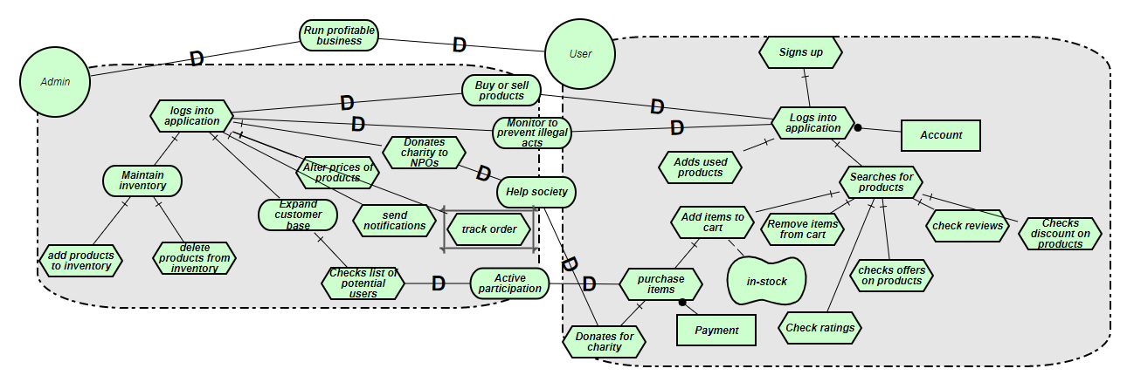

**3.2 Descriptions of goals :**

Application e-Store has two actors , User and Admin

**Admin:**

* Main Goal of Admin is to run profitable business. To achieve this Admin will display list of all products in different categories for sale.
* Goal of Admin is to expand user base. To make more sales , attract users and expand User base he often provides discounts and offers. To send promotional notification Admin saves user details like email Id.
* Goal of Admin is also to promote active participation of the users which is achieved by checking list of potential users who actually purchased the products.
* Goal of Admin is to collect money for charity from Users and donate it to Non Profitable Organizations.
* Goal of Admin is to maintain inventory and to alter list of products in the inventory according to sales and addition of new products by the user.
* Goal of Admin is to monitor all users to avoid forbidden activities.

**User:**

* Main Goal of User is to successfully buy or sell products. To achieve this User has to register in signup page providing all user details with a valid email.
* Goal of User is to get notification if there is any sale or offer on any products. To achieve this user has to provide valid email id while registering.
* Goal of User is to donate charity to help people in need and to contribute to the community.
* Goal of User is to be able to provide reviews and ratings to the products that he/she bought.

**3.3 Desired-State Scenarios :**

Admin should be able to successfully login into application using his credentials in the login form.

Admin after logging into his account should be able to add products and remove any undesired products from the inventory with ease.

Admin can alter the price of a particular product if needed

Admin checks the list of customers who bought the products and monitors the purchases.

User should be able to successfully create an account using his details im the signup form if he does not have an existing account.

User should be prompted with a message of account existence already if he tries to register again using the same details.

User when successfully logs into application should be able to search for desired products in the catalog.

User after successfully logging into application should be able to add his used products for sale and determine its price at his will.

User should be able to provide a review for a product or check reviews and ratings for the products he is searching for.

User should be able to check for any discounts available on the product.

User should be able to successfully remove any products from the cart if he does not wish to purchase them now or in later future.

User should be able to successfully purchase the products proceeding through the third party payment gateway without any hindrances.

User should be able to donate some amount for charity while purchasing the productif he is willing to.

**4. Functional Requirements:**

**4.1 Overview :**

Here in e-Store web-application the user signs up for buying or selling any product through this website and he can find the best deals on the product and can also have the option of selling his old products through this website depending upon the auction. User gets the notifications about the purchase through e-mail.Also, one good thing that is provided by this website is donating some percentage of the amount to charity as a goodwill.It is a responsive website where same webpage can be opened in all devices with any breakpoints responding as per screen size and orientation.

**4.2 Functional Model**

**4.2.1 Use Case Diagram**

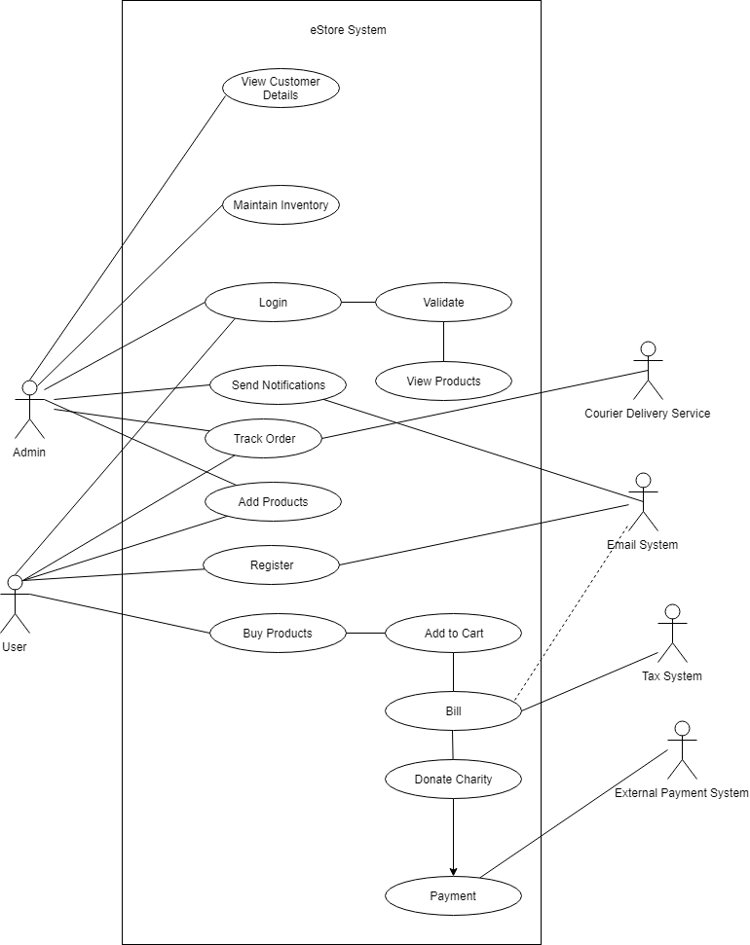

**4.2.2 User Stories**

As a User, I want to login with eStore, so that I can view all the products listed , buy products and also sell goodwill products.

As a Admin, I want to login with eStore, so that I can view products, add products for sale and also check customer details.

As a User, I must enroll to the system providing my details along with user Id and password so that i can login into application successfully.

As a User, in order to buy products I want to check the list of products available in the homepage so that i can make a decision on which product is the best.

As a User in order to sell my old products I want to provide details of my old product along with price so that other users can buy them.

As a User I should be able to sell my used products through the application by determining their prices so that i can estimate value of my good.

As a User I should be able to search for products in different categories such as

electronics, furniture, home improvements, arts , and automobiles etc. so that my

options wouldn’t be limited.

As a User I should be able to check the reviews , discounts, ratings, and offers on a product so that I can compare the products among one another and buy a suitable one.

As a User, I want to donate some money to charity along with bill so that i can help the society.

As an Admin I want to alter the prices of Items in order to give more discounts for active participation of customers so that i can run a profitable business.

As an Admin I want to check the potential users in order to expand my customer base by providing some or the incentives so that sales are increased.

As a Admin, I want to check all the details of customers who purchased or sold any products in the website so that i can keep a track of customer base.

As a Admin, I want to email Order details to Users who purchased products in the website so that they can keep track of their order.

**4.2.3 Behavior-Driven Scenarios :**

**User Stories 1:**

**Feature Name:** Login

**Participating Actors:** Administrator, Users

**Actor:** Administrator

**Related Scenarios:**

**Scenario One:**

**Given** credentials entered by administrator are correct

**When A**dministrator is redirected to home page

**Then** Administrator has rights to approve the users requesting access and can disable and enable certain features.

**Scenario Two:**

**Given** credentials entered by administrator are incorrect

**When A**dministrator is redirected to Login page

**Then** It is prompted to enter him correct credentials.

**Actor:** Users

**Related Scenarios:**

**Scenario One:**

**Given** credentials are entered by user

**When** credentials check is made

**Then** user is redirected to the home page

**Scenario Two:**

**Given** credentials are entered by user are incorrect

**When** user is redirected to the Login page

**Then** It is prompted to enter him correct credentials.

**User Stories 2:**

**Feature Name:** Sign Up

**Participating Actors:** Users

**Actor:** Users

**Related Scenarios:**

**Scenario One:**

**Given** user details are submitted in sign up page

**When** user details are stored in database

**Then** user is directed to login page from where he can proceed with login details.

**User Stories 3:**

**Feature Name:** Product Search

**Actors:** Administrator, Users

**Related scenarios:**

**Scenario One:**

**Given** a home page which consists of various options of which product search is the first one.

**When** user clicks the product search

**Then** user is directed to a page which consists of several products listed and will be able to filter them based on a few criteria as price, material etc.

**Scenario Two:**

**Given** user successfully navigates to goodwill page

**When** user clicks the on the add products

**Then** user can upload used products for sale.

**User Stories 4:**

**Feature Name:** Product Details Page

**Actor:** Administrator, Users

**Scenario one:**

**Given** user successfully navigates to product details page

**When** user clicks buy product

**Then** user can see and purchase products

**User Stories 5:**

**Feature Name:**  Sell products

**Actor:** Administrator, Users

**Related scenarios:**

**Scenario One:**

**Given** Admin successfully navigates to home page.

**When** user clicks sell products

**Then** Admin can add products and add details to product description along with number of items available and price.

**Scenario Two:**

**Given** user successfully navigates to goodwill page.

**When** user clicks add products

**Then** user can add products in goodwill page and all the details of the product along with price.

**User Stories 6:**

**Feature Name:**  View customers page

**Actor:** Administrator

**Related scenarios:**

**Scenario One:**

**Given** Admin successfully logs into application.

**When** user Admin clicks check customer details.

**Then** Admin can monitor all the customer details who purchased goods from this website.

**User Stories 7:**

**Feature Name :** Buying products

**Actor :** Users

**Related Scenarios :**

**Given** user successfully navigates product details page

**When** user views the products to purchase

**Then** user can select all the products and buy them providing payment details.

**4.2.4 Screen Mockups :**

**Signup Page:**

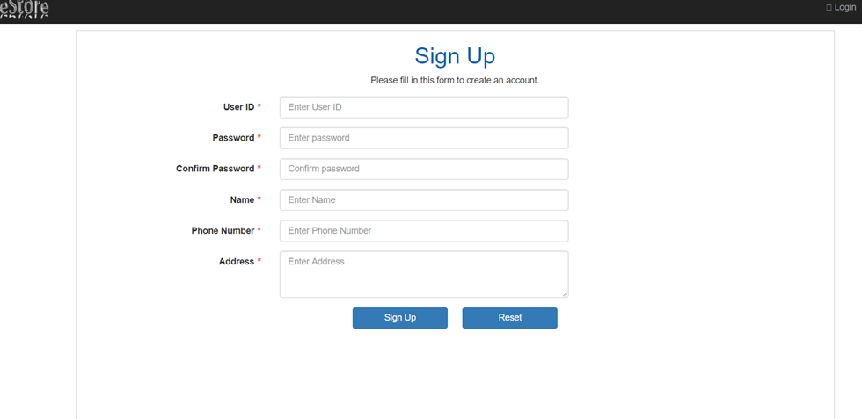

**Login page:**

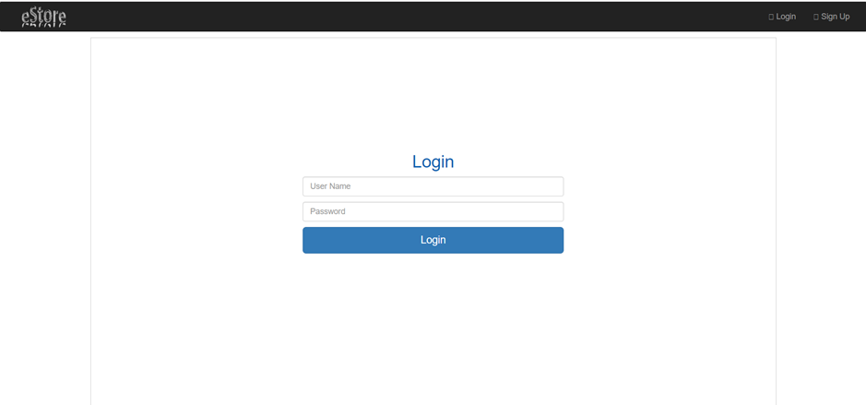

**Home Page:**

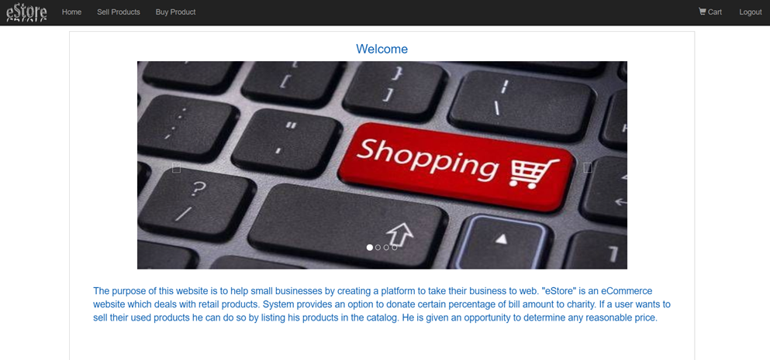

**Purchase Page:**

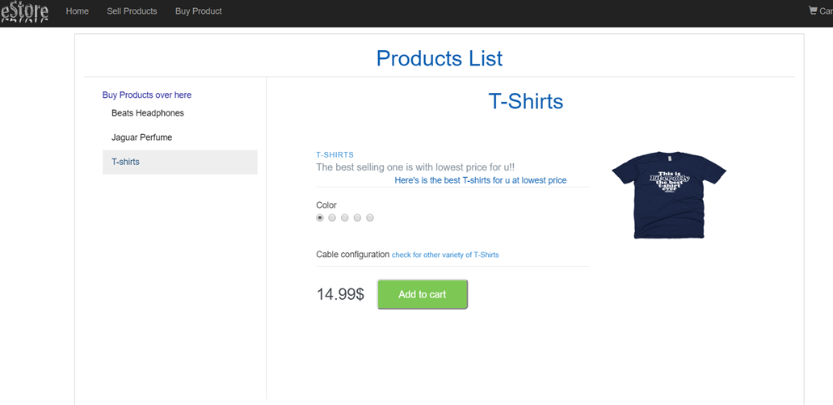

**Sell Item Page:**

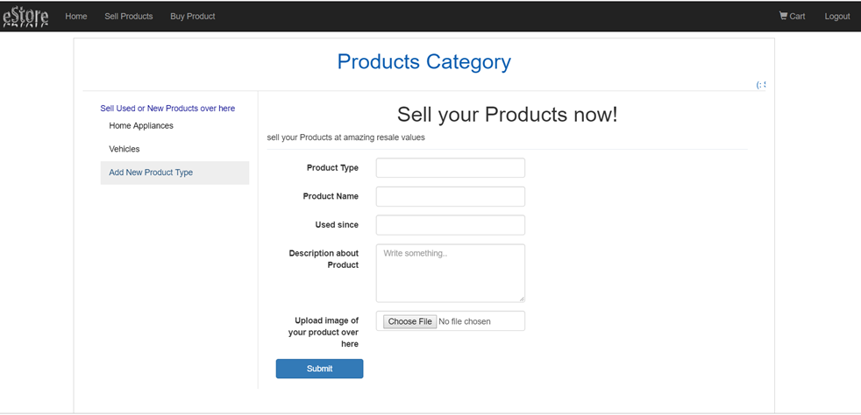

**Add to Cart Page:**

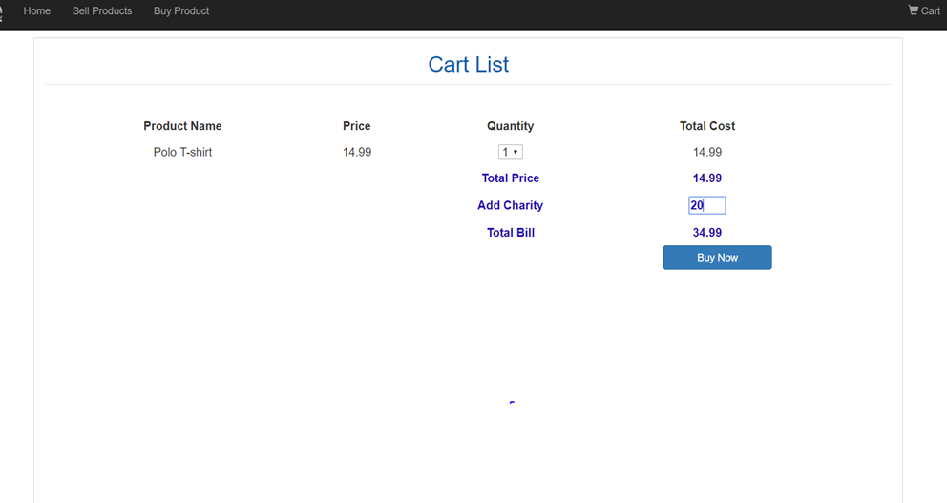

**Payment Page:**

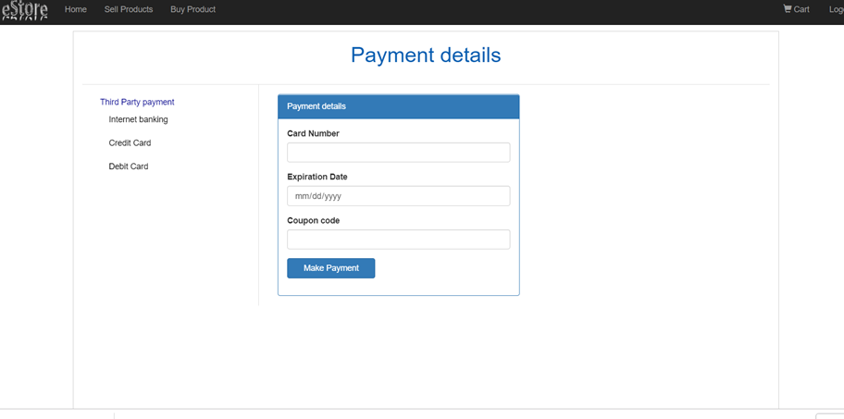

**4.2.5 Navigational Paths :**

On load of page User will be navigated to Login Page. If User is not registered he can register using sign up link . Once user clicks on sign up link user will be navigated to sign up page. Once user registers using signup page he will be navigated to login page. Once user login to system using login credentials user will be navigated to home page . If user wants to purchase products user will be navigated to purchase page on click of link present in navigation menu. If user adds products to cart and clicks on cart , User will be navigated to Add to Cart page to check all added products and their prices. User can remove or add any product in Add to cart page before confirming order. User can add charity amount as a part of bill in add to cart page before confirming his order. Once User confirms his/her order , User will be navigated to payment page to provide payment details. Once payment is done User will get confirmation notification to his email. If user want to sell any used products he will click on Sell Items link which is part of navigation menu in home page , User will be navigated to Sell your product page. Once user adds product details in Sell your product page he/she will be navigated to Purchase page to check his added product details.

**4.3 Object Model :**

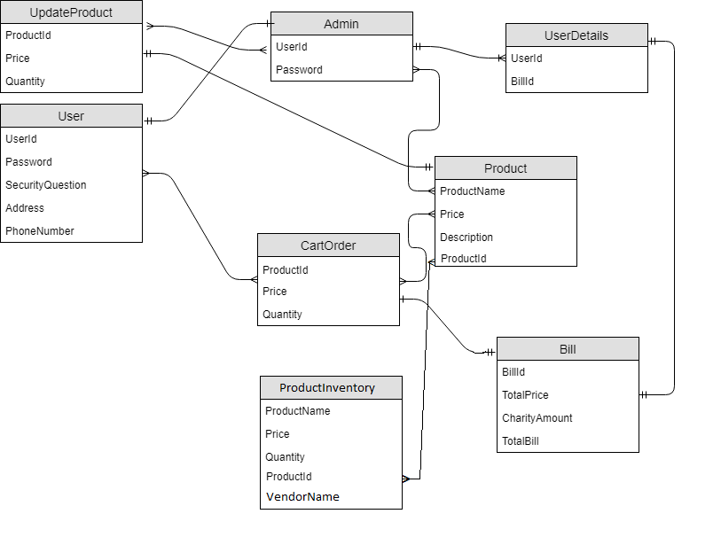

**4.4 Dynamic Models :**

**4.4.1 Interaction/sequence models :**

“As a User, I want to login with eStore, so that I can view all the products listed and buy products”

In Below sequence diagram we consider User trying to buy products from eStore. First User has to Enter user credentials inorder to login. EStore application validates user details, If valid User will be allowed to buy any product. To Buy a product user will check all the products listed and selects a product. If product is available in inventory selected product will be added to cart and asks User whether he/she wishes to continue shopping. If User wishes to continue shopping , User will select product again If not he can checkout from cart. Once User checkout from cart Bill will be generated. Once user Pays the bill respective items will be removed from product inventory and confirmation notification will be sent to user.

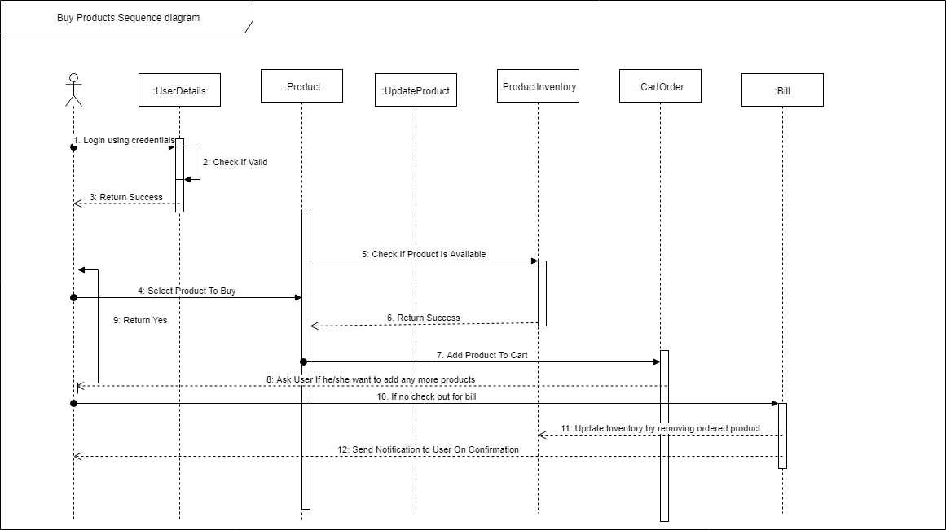

“As a User in order to sell my old products I want to provide details of my old product along with price so that other users can buy them.”

“As an Admin in order to sell my products I want to provide details of product along with price so that other users can buy them.”

Below is sequence diagram for above two user stories.Admin or User can add products for sale in the application. User/Admin should login using their credentials.Credentials will be validated against each user details. On success User/Admin will be given an option to add product details of the product that he/she want to sell. Entered Product will be updated in Product Inventory. After Successful addition of product to inventory , User/Admin will be notified. User/Admin can add more products if wanted.

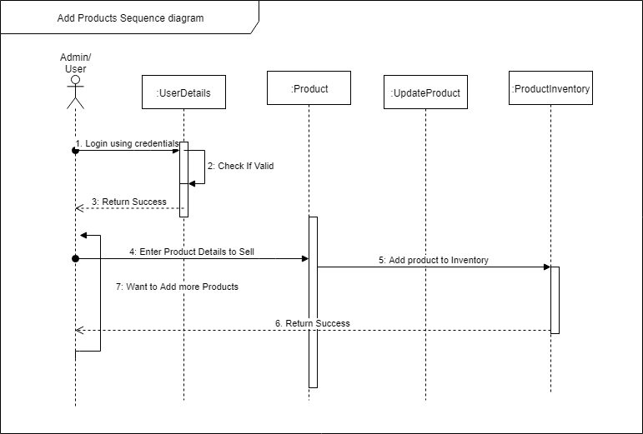

**4.4.2 State Models** :

Below is UML statechart diagram of eStore. Initially If User is first time user then he will be navigated to signup page to register for application. On Registration user will be navigated to login page to enter credentials. Entered credentials will be verified from those in database if user is not valid user then he/she will be asked to re-login. If User provides invalid credentials for more than 3 times continuously then entered user Id will be locked.If entered user credentials are valid then user can access application. He/she can choose either to buy products or sell products.If user selects a product then that product will be added to cart. On check out of cart Order will be confirmed and navigated to payment page. On successful transaction order summary will be notified to user. If user adds product details then that product will be updated in the inventory. On successful update product list will be displayed to user along with updated products from the inventory. When even user clicks on logout user will be navigated out of the application. 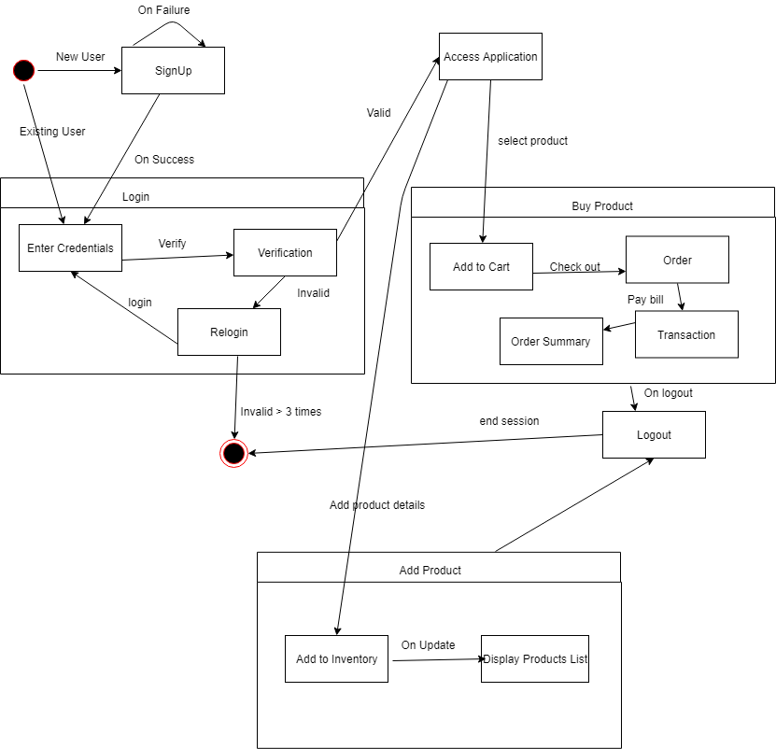

**5. Other Requirements**

**5.1 Quality Requirements**

**5.1.1 Nonfunctional goals:**

**Usability**

UI of application is clear without any confusion for User to use.

Flow of actions are simple, user need to click appropriate link from home page to navigate to respective page.

We considered clear design for our application to hase ease of access for even first time users to be able to sell or purchase their products successfully.

As users will be using our application from different geographical locations , multi language support for the application should be provided.

**Performance**

Any number of Users can access the application at same time without any issue or failure in the system.

Performance of system should be good even different users login into Application at the same time using different User Ids.

Application behaviour should not change even if user is using application for long time in any session.

Provide all possible navigation page links in header so time taken for navigation will be less than 3 seconds.

Performance of application depends upon the configuration of device the user is using.

**Supportability**

Application should be able to load in any environment and in any operating system.

Application should be loaded in any device like tablet, mobile or desktop and in any operating system like windows, Android or IOS.

Application should be loaded in any browser like google chrome, internet explorer or saffari.

Depending upon stakeholder requirement some products should be enabled or disabled based on geographical locations.

**Legal**

User details are confidential and should not be revealed to any one.

Copyright should be displayed in the application.

**Security**

Provide authorized access to the Users for buying or selling products to prevent brute force attack during login. User should be able to access application only if he/she can login to it using authorised User Id and password.

If Application is accessed using User details in unusual location or device , notification mail will be sent to User registered email-id.

User credentials like password should not be stored in cookies. User account should logout if there is inactivity for long period of time.

**Safety**

Users are not supposed to share his/her user details with others.

Users should not provide incorrect delivery address.

Users should log out of the application if he/she used application in public or other device.

**Interface**

Actors in application are User and Admin. Application Interface for User and Admin should be according to stakeholder requirement.

Depending on the role of actor privileges to view or access Application interface should be provided.

All the webpages should be uniform throughout the application.

**5.1.2 Goal question metric breakdown**

**Goal One:** Prevents unauthorized access to the application protecting data.

**Question one:** Does the application ensure strong password policy.

**Question Two:** Does the application implement any mechanism to prevent brute force attack

**Metric:** Access control metrics, security.

**Goal Two:** Customer ease of accessing the application.

**Question one:** Does the application provide easy navigation throughout the application to the customer.

**Metric one:** key stroke counts: Number of keystrokes, mouse clicks and other operations did the customer use to complete the task. Number of mouse clicks made by each customer for navigating and purchasing the required product is calculated.

Question two: Does the application allow user to easily add and remove products from the cart whenever required.

**Metric two:** Opinion poll: A questionnaire provided at the end of the application enables us to capture to what extent the user feels about the ease in accessing application.

**Goal Three:** Admin or Customer ease of adding items to inventory

**Question one:** Does the application provide easy access to admin or customer to add items to inventory while trying to sell items.

**Metric one:** Task time: How much time does the admin or customer spend on adding the product to inventory.

**Metric two:** Flexibility.

**5.2 Formal Specifications:**

**5.2.1 Overview**

**Authorizing the customer and Admin login**

When a rogue customer or rogue admin tries to login into application he should be denied access to application. We should be able to provide a brute force mechanism against any brute force attacks and ensure the application has strong password policy to provide security. While customer or admin tries to login to application we will validate login Id and password with existing Id and existing present in the database. If login Id and password matches with data present in database then user will be provided access to application.If not user will not be provided access to the application.

**Ease Access To Add Items To Inventory**

When customer or admin tries to add items into inventory he should be provided with ease access to do so. We should ensure that user or admin will be provided flexible options to add items to inventory without making it tedious task.

**Ease to pay total bill**

When customer tries to pay selected items from the cart for payment he/she should be given ease access by providing customer total bill amount so that he can check his total bill and proceed for payment.

**Ease Access To Add Items To Cart**

When customer tries to buy items he should be provided with ease access to add selected product item into cart. We should ensure that user will be provided flexible options to add items to cart without making it difficult. Customer should be able to checkout cart items easily.

**5.2.2 Formal specification**

mod MYLIST* {

protecting(NAT) -- predefined type: natural numbers

[List] -- sort declaration

-- signatures

op inventory : -> List

op loginlist : -> List

op orderlist : -> List

op add-to-inventory : List Nat -> List

op add-to-cart : List Nat -> List

op validate : List Nat -> Bool

op totalbill : List -> Nat

op cons : List Nat -> List

op empty-list : -> ?Nat

op firstproduct : List -> Nat

op lastproducts : List -> List

-- axioms

var V : Nat

var L : List

var E : Nat

var S : Nat

-- add product to database when user tries to sell a product

eq add-to-inventory(inventory,V) = cons(inventory,V).

eq add-to-inventory(cons(L,V),E) = cons(cons(L,V),E).

-- validate UserId from data base

eq validate(loginlist,V)= false .

eq validate(cons(loginlist,V),V) = true .

eq validate(cons(L,V),V) = true .

eq validate(cons(L,V),E) = validate(L,E).

-- add product to cart when user tries to buy any product

eq add-to-cart(orderlist,V) = cons(orderlist,V).

eq add-to-cart(cons(L,V),E) = cons(cons(L,V),E).

-- to get first product item price

eq firstproduct (orderlist) = empty-list .

eq firstproduct (cons(orderlist,V)) = V .

eq firstproduct (cons(L,V)) = firstproduct (L) .

-- to get list of product items except first one.

eq lastproducts (orderlist) = orderlist .

eq lastproducts (cons(orderlist,V)) = orderlist .

eq lastproducts (cons(L,V)) = cons(lastproducts(L),V).

-- to get total bill value to proceed payment

eq totalbill (orderlist) = 0 .

eq totalbill (cons(orderlist,V))= V .

eq totalbill (cons(L,V))= firstproduct (cons(L,V)) + totalbill (lastproducts (cons(L,V))) .

}

**5.2.3 URL to specification code**

eStore project code is in github version control in below URL

https://github.com/SushmaSakala/CSCI8700-SSD-Spartans.git

**5.3 External System Interfaces**

* eStore system should communicate with courier delivery services like fedex or UPS to track product delivery to customer.
* eStore system should communicate with tax system in respective geographical locations to calculate tax on respective categories.
* eStore system should communicate with external payment system to check all possible payment options it can provide for the customer and to validate user payment details.
* eStore system should communicate with company brand manager to display warranty of product if applicable.
* eStore system should communicate with vendors for possible offers and promotions.
* eStore system uses email system to send notifications about sale and promotional discount offers to all customers.